Suppose you want to fork another repository public/private on github.com to your account, you need to fork that repository.

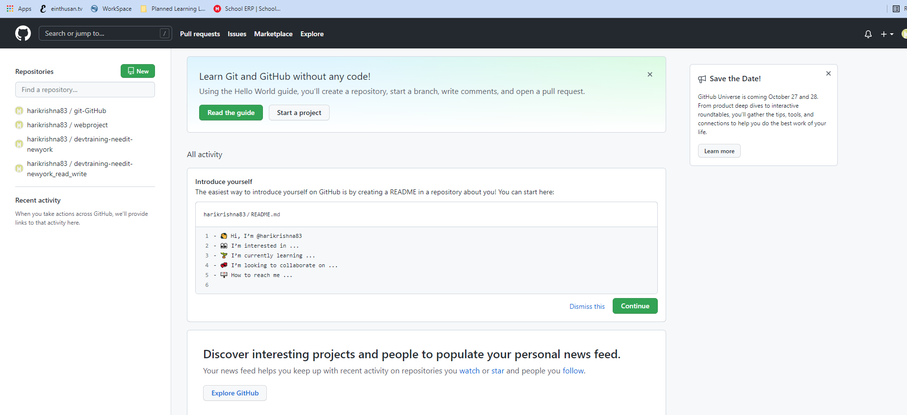

Open another tab on your browser and search for ninja scm github repository as shown below.

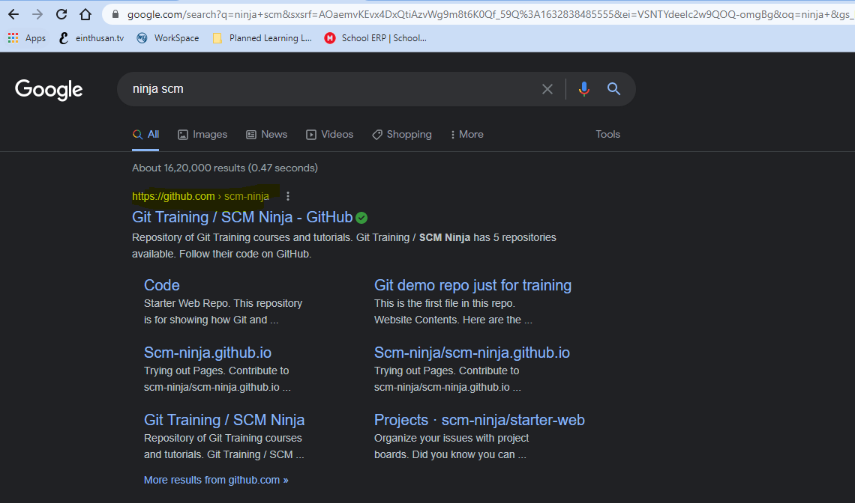

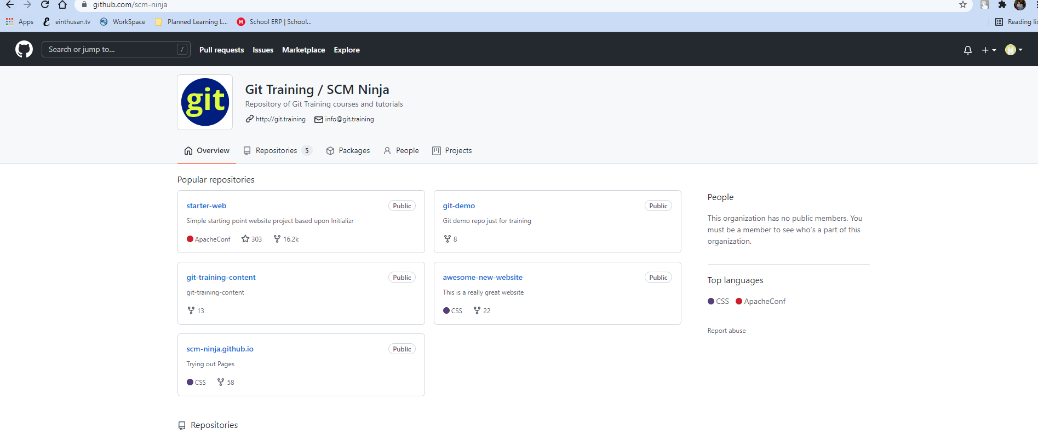

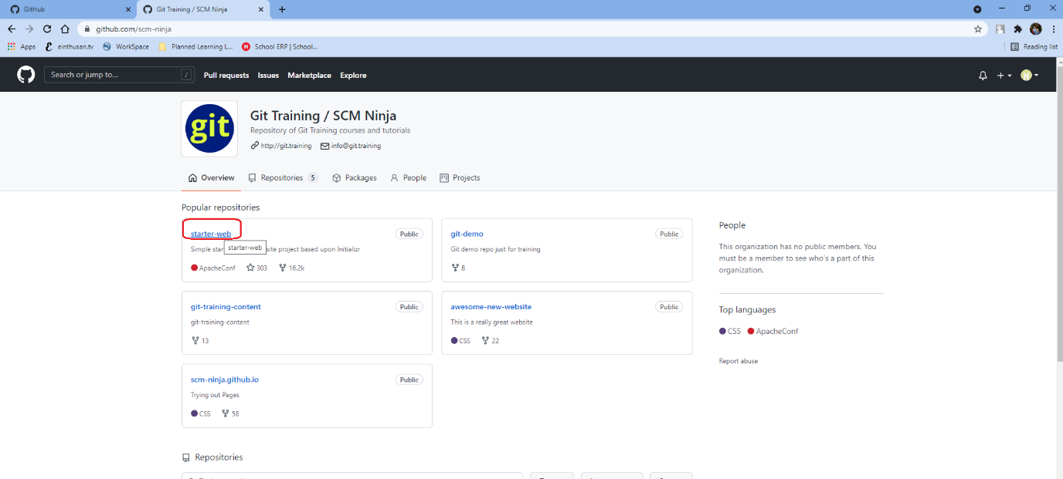

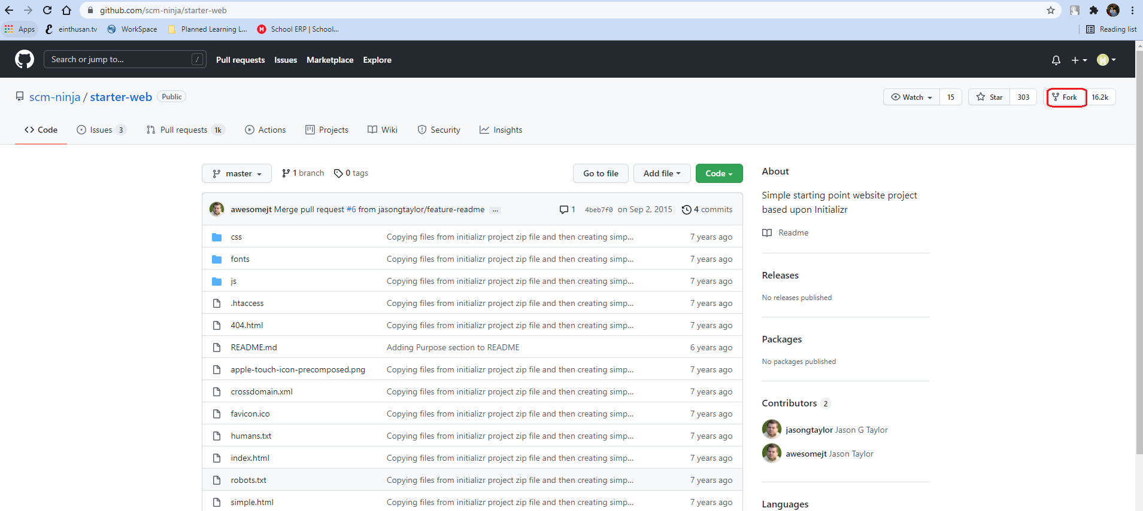

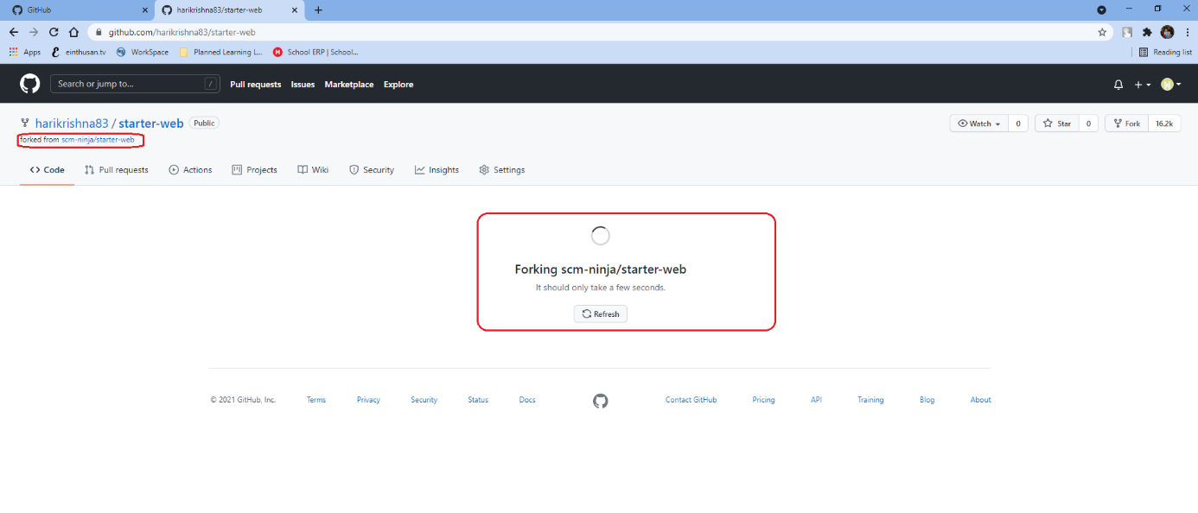

Now refresh your github.com and see whether this started-web web repository from ninja scm had been forked to your account or not.

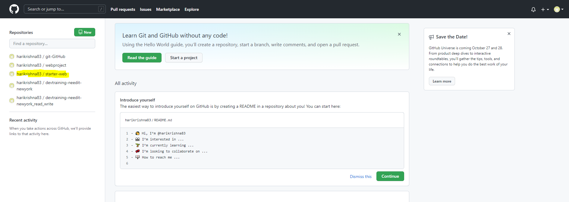

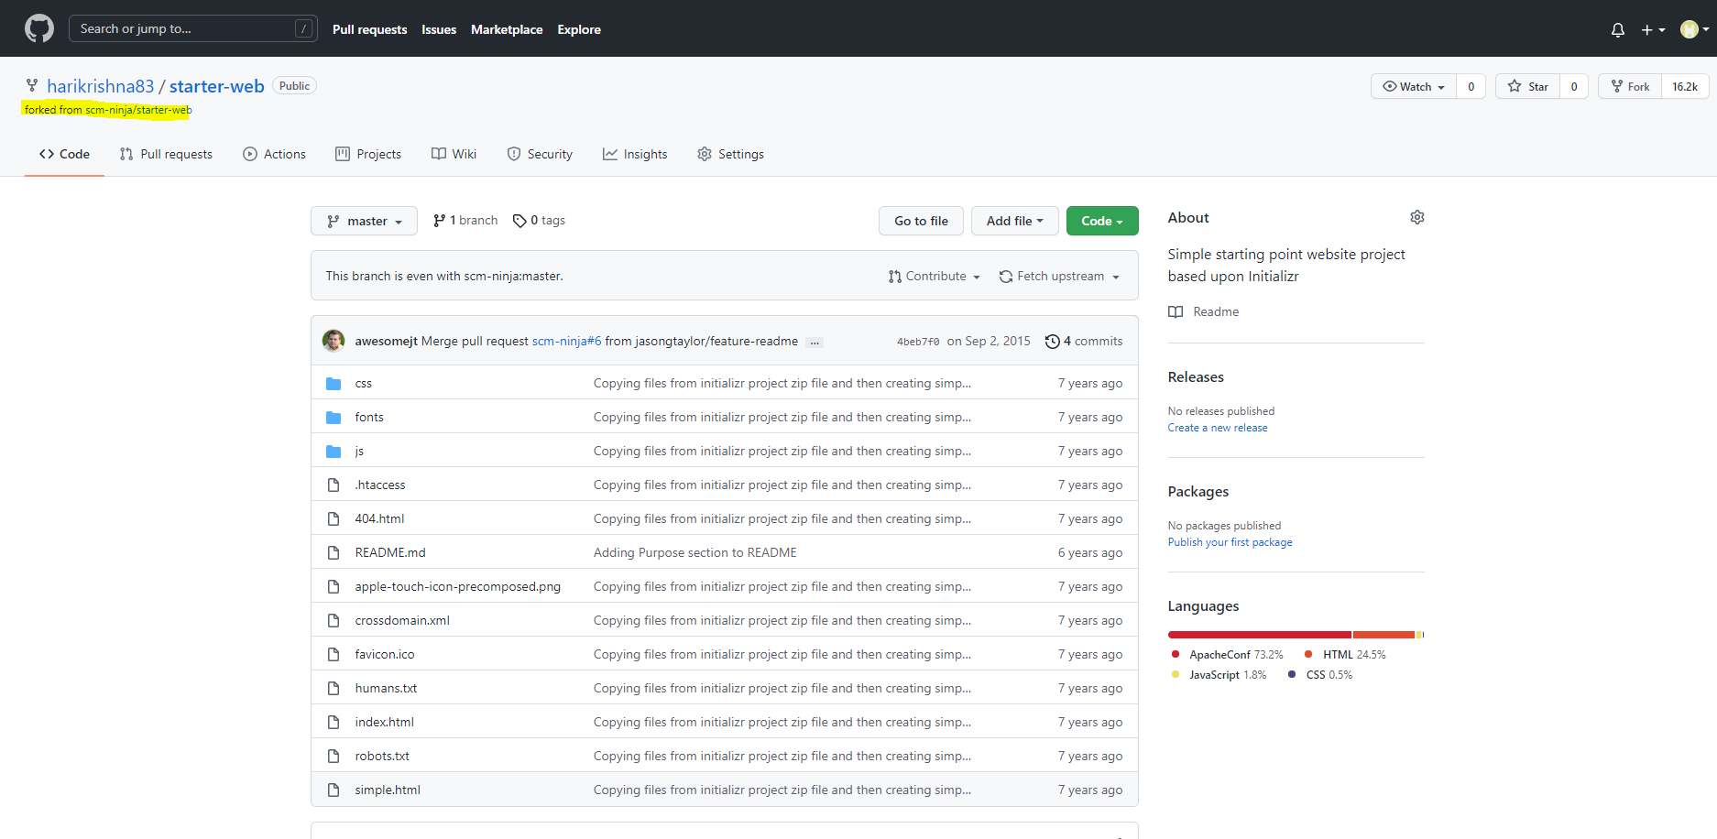

Basically ninja scm was developed by someone and uploaded it publicly, we had forked that project into our github.com and will customize according to our needs.

Now we will see how can clone this project to our local repository.

Now this time I will try to fetch the github repository to our local repository by using the ssh protocol

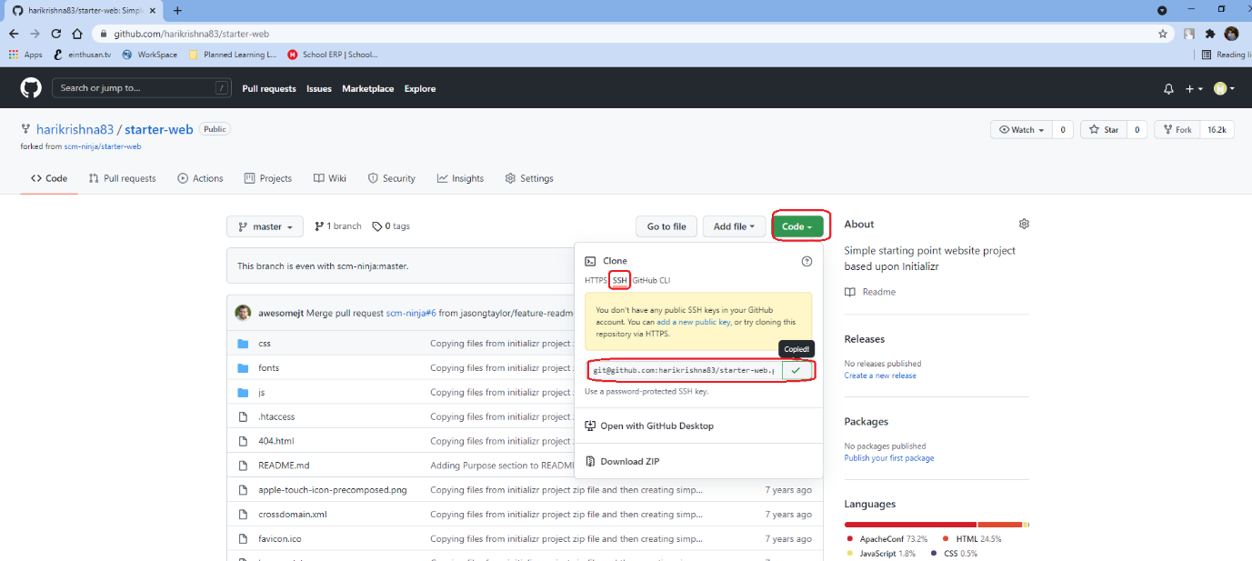

Create a directory as shown below and enter into that directory.

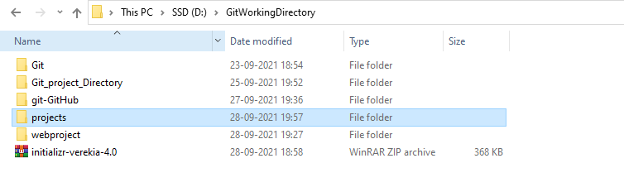



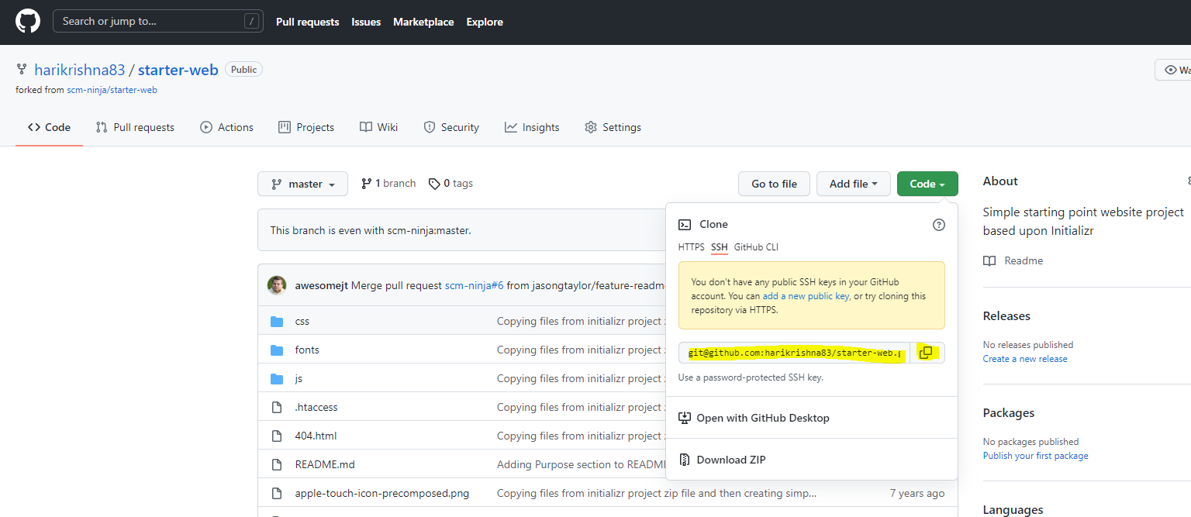

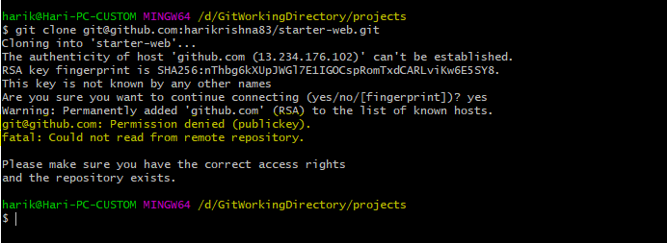

The above error permission denied happens because we didn’t added any ssh keys of our local repository to our github.com

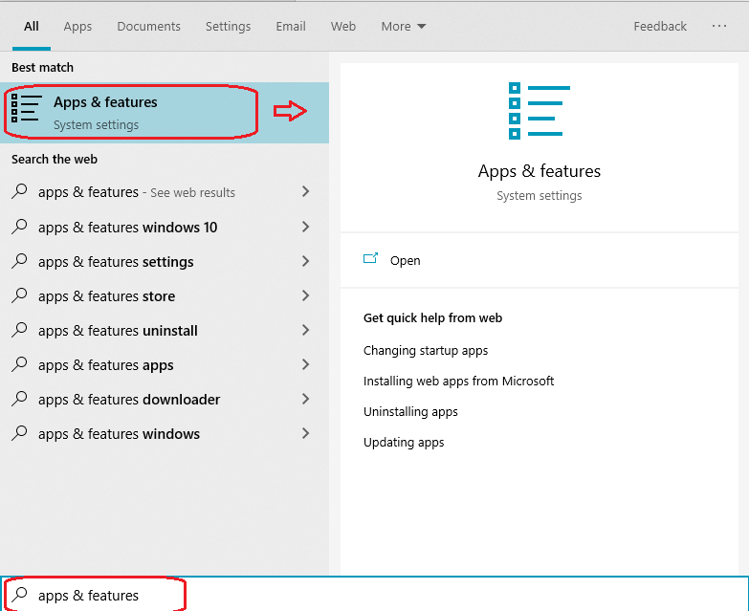

Click on Optional features.

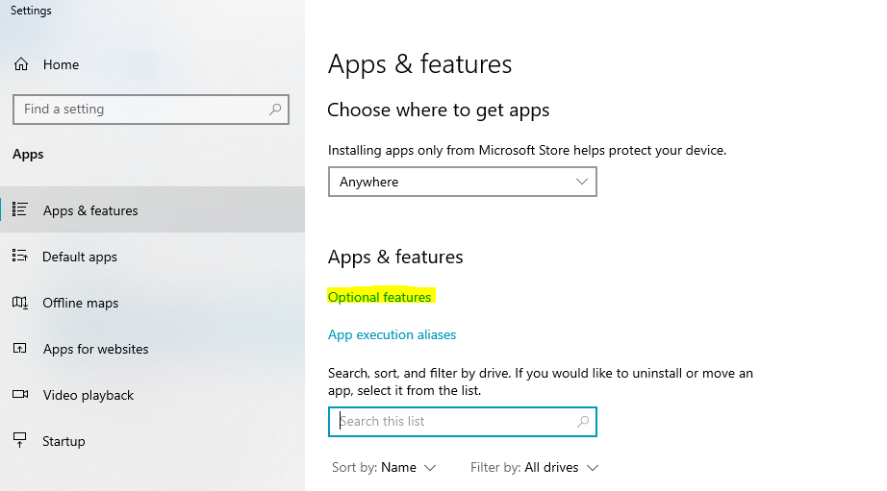

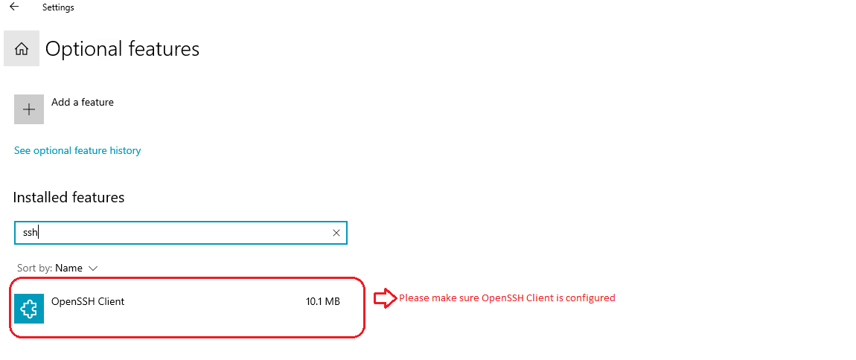

Once OpenSSH Client plugin installed, open the command prompt with administrator privileges.

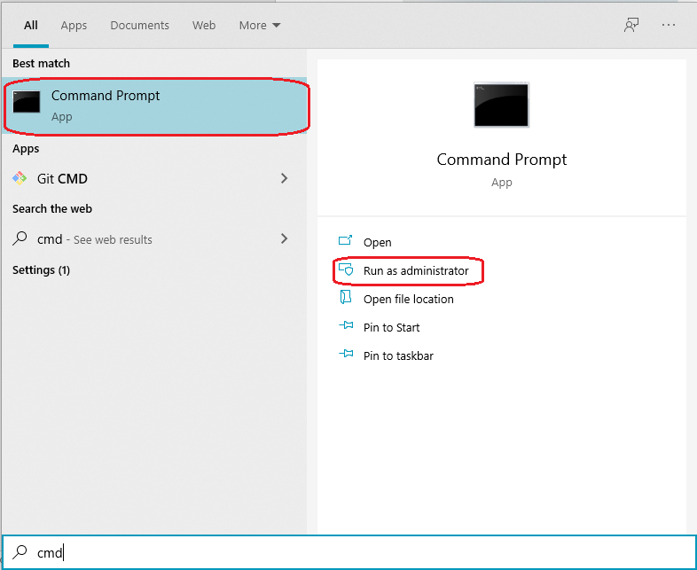

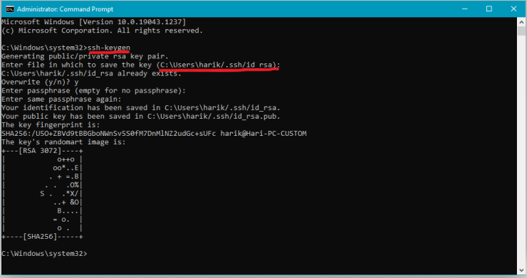

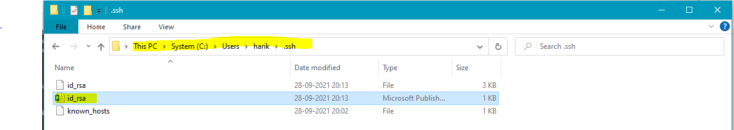

Open that file in any editor and copy the key.

Login to github.com and click on settings as shown below.

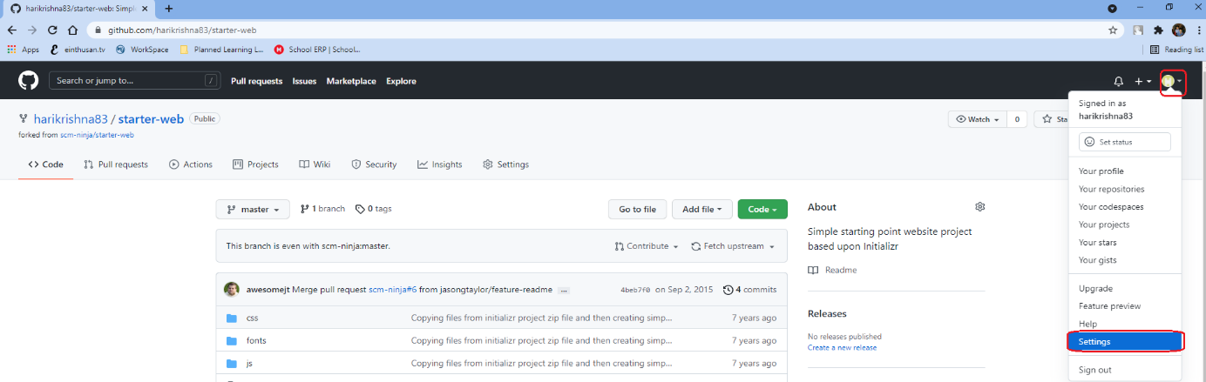

Click on SSH and GPG keys and add new key by clicking on “New SSH key”.

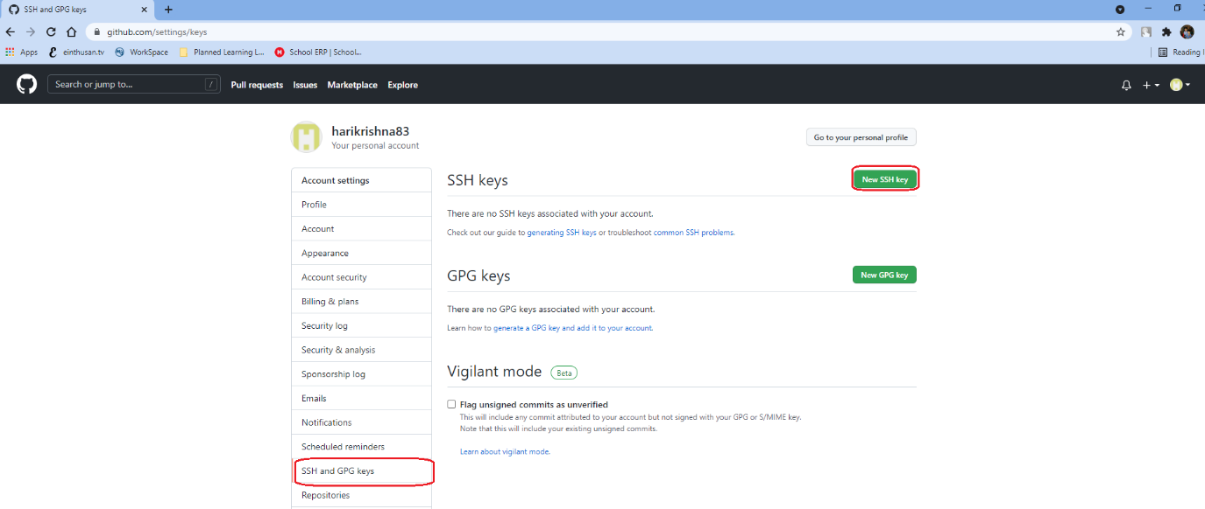

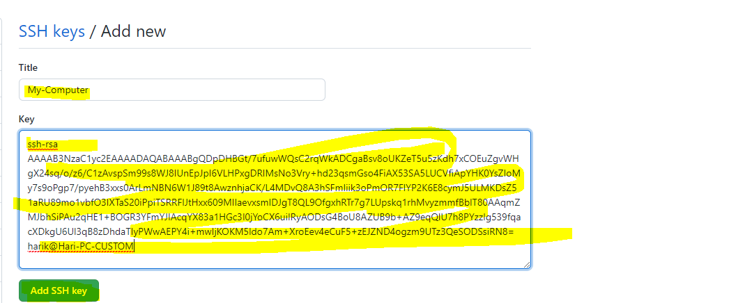

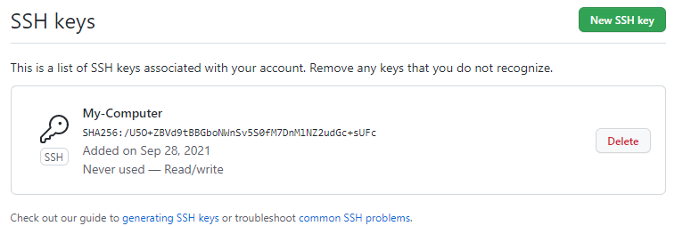

Now you can try pull the code from the github.com to local repository.

